At Peter Pan we aim to:

- Provide high quality care and education for children below statutory school age;
- Work in partnership with parents to help children to learn and develop;
- Add to the life and well-being of the local community
- Offer children and their parents a service that promotes equality and values diversity;

Parents

At Peter Pan Parents are regarded as members of our setting who have full participatory rights. These include a right to be:

- Valued and respected;
- Kept informed;
- Consulted;
- Involved and included at all levels.

Here at Peter Pan we aim to ensure that each child:

- Is in a safe and stimulating environment;
- Is given generous care and attention, because of our ratio of qualified staff to children, as well as volunteer helpers;
- Has the chance to join with other children and adults to live, play, work and learn together;
- Is helped to take forward her/his learning and development by being helped to build on what she/he already knows and can do;
- Has a personal key person who makes sure each child makes satisfying progress;
- Is in a setting that sees parents as partners in helping each child to learn and develop
- Is in a setting in which parents help to shape the service it offers.

Children’s development and learning

We aim to ensure that each child:
- Is in a safe and stimulating environment;
- is given generous care and attention, because of our ratio of qualified staff to children as well as volunteer parent helpers;
- has the chance to join in with other children and adults to live, play, work and learn together;
- is helped to take forward her/his learning and development by being helped to build on what she/he already knows and can do;
- has a personal key person who makes sure each child makes satisfying progress;
- is in a setting that sees parents as partners in helping each child to learn and develop; and
- is in a setting in which parents help to shape the service it offers.

The Early Years Foundation Stage

The provision for children's development and learning is guided by the Early Years Foundation Stage (DfE 2012). Our provision reflects the four overarching principles of the Statutory Frame work for the Early Years Foundation Stage.

A Unique Child
- Every child is a unique child who is constantly learning and can be resilient, capable, confident and self assured.

Positive Relationships
- Children learn to be strong and independent through positive relationships.

Enabling Environments
- Children learn and develop well in enabling environments, in which their experiences respond to their individual needs and there is a strong partnership between practitioners, parents and carers.

Learning and Development
- Children develop and learn in different ways and at different rates, The framework covers the education and care of all children in early years provision including children with special educational needs and disabilities.

How we provide for development and learning
Children start to learn about the world around them from the moment they are born. The care and education offered by our setting helps children to continue to do this by providing all of the children with interesting activities that are appropriate for their age and stage of development.

The Areas of development and Learning comprise:
Prime Areas
- Personal, social and emotional development.
- Physical development.
- Communication and language.

Specific Areas
- Literacy.
- Mathematics
- Understanding the world
- Expressive arts and design.

For each area, the level of progress that children are expected to have attained by the end of the Early Years Foundation Stage is defined by the Early Learning Goals. These goals state what it is expected that children will know, and be able to d, by the end of the reception year of their education.

The Development Matters guidance sets out eh likely stages of progress a child makes along their learning journey towards the Early Learning Goals. Our setting has regard to these matters when we assess children and plan for their learning. Our programme supports children to develop the knowledge, skills and understanding they need for:

Personal, social and emotional development
- making relationships;
- self confidence and self awareness; and
- managing feelings and behaviour.

Physical development
- moving and handling; and
- health and self-care.

Communication and language
- listening and attention;
- understanding; and
- speaking.

Literacy
- reading; and
- writing

Mathematics
- numbers; and
- shape, space and measure.

Understanding the world
- people and communities;
- the world; and
- technology.

Expressive arts and design
- exploring and using media and materials; and
- being imaginative.

Our approach to learning and development and assessment

Learning through play
Play helps young children to learn and develop through doing and talking, which research has shown to be the means by which young children learn to think. Our setting uses the practice guidance Early Years Foundation Stage to plan and provide a range of play activities which help children to make progress in each of the areas of learning and development. In some of these activities children decide how they will use the activity and, in others, an adult takes the lead in helping the children to take part in the activity. In all activities information from the practice guidance to the Early Years Foundation Stage has been used to decide what equipment to provide and how to provide it.

Assessment
We assess how young children are learning and developing by observing them frequently. We use information that we gain from observations, as well as from photographs or videos of the children, to document their progress and where this may be leading them. We believe that parents know their children best and we ask them to contribute to assessment by sharing information about what their children like to do at home and how they as parents are supporting development.

We make periodic assessment summaries of children’s achievement based on our ongoing development records. These form part of children’s records of achievement. We undertake these assessment summaries at regular intervals as well as times of transition, such as when a child moves into a different group or when they go on to school.

Records of achievement

This setting keeps a record of achievement for each child. Staff and parents working together on their children’s records of achievement is one of the ways in which the key person and parents work in partnership. Your child’s record of achievement helps us to celebrate together her/his achievements and to work together to provide what your child needs for her/his well-being and to make progress.

Your child’s key person will work with you to keep this record. To do this you and she/he will collect information about your child’s needs, activities, interests and achievements. This information will enable the key person to identify your child’s stage of progress. You and the key person will then decide on how to help your child move on to the next stage.

Working together for your children

At Peter Pan, we maintain the ratio of adults to children in accordance with Ofsted regulations and the Welfare Requirements. We also have volunteer helpers where possible to complement these ratios. This enables us to:

- Give time and attention to each child;
- Talk with the children about their interests and activities;
- Help children to experience and benefit from the activities we provide
- Allow the children to explore and be adventurous in safety.

We are open for 51 weeks each year.

We are closed for normal business during the Christmas break and Bank Holidays.
We are open for 5 days per week
We open at 8.00 a.m. – 5.00 p.m. Mon – Thurs and 8.00a.m. – 1.00 p.m. Friday

We provide care and education for young children between the ages of birth and 5yrs

How parents take part in the setting

Peter Pan recognises parents as the first and most important educators of their children. All of the staff see themselves as partners with parents in providing care and education for their child. There are many ways in which parents take part in making the setting a welcoming and stimulating place for children and parents, such as:

- Exchanging knowledge about their children’s needs, activities, interests and progress with the staff;
- Helping at sessions of the setting;
- Sharing their own special interests with the children;
- Helping to provide, make and look after the equipment and materials used in the children’s play activities;
- Being part of the management of the setting;
- Taking part in events and informal discussions about the activities and curriculum provided by the setting;
- Joining in community activities in which the setting takes part;
- Building friendships with other parents in the setting.

Key person and your child

Our setting uses a key person approach. This means that each member of staff has a group of children for whom she/he is particularly responsible. Your child’s key person will be the person who works with you to make sure what we provide is right for your child’s particular needs and interests. When your child first starts at the setting, she/he will help your child to settle and throughout your child’s time at Peter Pan, she/he will help your child to benefit from the setting’s activities.

Learning opportunities for adults

As well as gaining qualifications in early years care and education, the setting staff take part in further training to help them to keep up-to-date with thinking about early years care and education. The setting also keeps itself up-to-date with best practice in early years care and education, as a member of the Pre-school Learning Alliance, through early years journals and publications and through training courses held by the local Early Years Team and local colleges.

Peter Pan’s timetable and routines

At Peter Pan we believe that care and education are equally important in the experience which we offer children. The routines and activities that make up the day in the setting are provided in ways that:

- Help each child to feel that she/he is a valued member of the setting;
- Ensure the safety of each child;
- Help children to gain from the social experience of being part of a group;
- Provide children with opportunities to learn and help them to value learning.

The Session

We organise our sessions so that the children can choose from, and work at, a range of activities and, in doing so, build up their ability to select and work through a task to its completion. The children are also helped and encouraged to take part in adult-led small and large group activities which introduce them to new experiences and help them to gain new skills, as well as helping them to learn to work with others. Outdoor activities contribute to children’s health, their physical development and their knowledge of the world around them. The children have the opportunity, and are encouraged, to take part in outdoor child-chosen and adult-led activities, as well as those provided indoors.

Snacks and meals

At Peter Pan we make snacks and meals a social time at which children and adults eat together. We plan the snacks so that they provide the children with healthy and nutritious food. Do tell us about your child’s dietary needs and we will make sure that these are met.

Policies

Copies of Peter Pan’s policies and procedures are available for you to see at the setting.

Our policies help us to make sure that the service we provide is of high quality and that being part of the setting is an enjoyable and beneficial experience for each child and her/his parents.

The staff and parents of Peter Pan work together to adopt the policies and they all have the opportunity to take part in the annual review of the policies. This helps us to make sure that the policies are enabling the setting to provide a quality service for its members and the local community.

Safeguarding children

Our setting has a duty under the law to help safeguard children against suspected or actual ‘significant harm’.

Our employment practices ensure children against the likelihood of abuse in our settings and we have a procedure for managing complaints or allegations against a member of staff.

Our way of working with children and their parents ensures we are aware of any problems that may emerge and can offer support, including referral to appropriate agencies when necessary, to help families in difficulty.

Special needs

As part of Peter Pan’s policy to make sure that its provision meets the needs of each individual child, we take account of any special needs a child may have. The setting works to the requirements of the 1993 Education Act and The Special Educational Needs Code of Practice (2001)

Our Special Educational Needs Co-ordinator is Cassie Venus.

The Management of the setting

A parent management committee – whose members are elected by the parents of the children who attend the setting – manages the setting. The elections take place at our Annual General Meeting. The committee is responsible for:

- Managing the settings finances;
- Employing and managing the staff;
- Making sure that the setting has, and works to, policies that help it to provide a high quality service;
- Making sure that the setting works in partnership with the children’s parents.

The Annual General Meeting is open to the parents of all of the children who attend the setting, it is our shared forum for looking back over the previous year’s plan.

Fees

The fees are payable monthly in advance. Fees must still be paid if the children are absent . If your child has to be absent over a long period of time, talk to Sally Titmus who is the Manager of Peter Pan.

For your child to keep her/his place at the setting, you must pay the fees. We are in receipt of nursery education funding for three and four year olds; where funding is not received, then fees apply.

Starting at Peter Pan

The first days:
We want your child to feel happy and safe with us. To make sure that this is the case, the staff will work with you to decide on how to help your child to settle into the setting. The setting has a policy about helping children to settle into the setting: a copy is available from Sally Titmus or Paula Gee.

Clothing
We provide protective clothing for the children when they play with messy activities. We encourage children to gain the skills that help them to be independent and look after themselves. These include taking off and putting on outdoor clothes. Clothing that is easy for them to manage will help them to do this.

We hope that you and your child enjoy being members of our setting and that you find taking part in our activities interesting and stimulating. The staff are always ready and willing to talk with you about your ideas, views or questions.

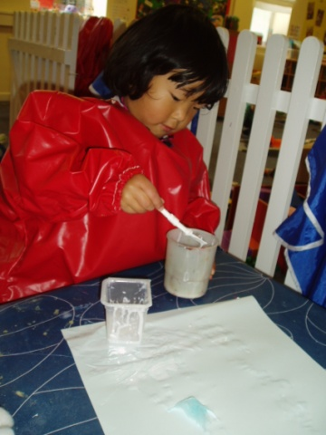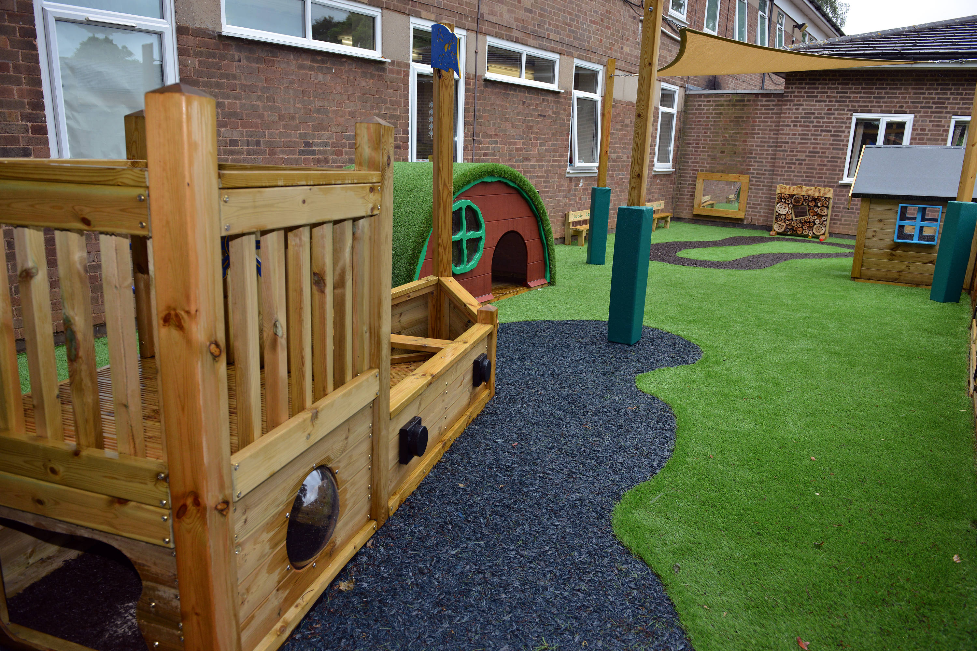

Enjoying creative development Our outdoor environment for under three’s
in the self resourcing area. Gives babies and children the opportunity
to explore and play safely.
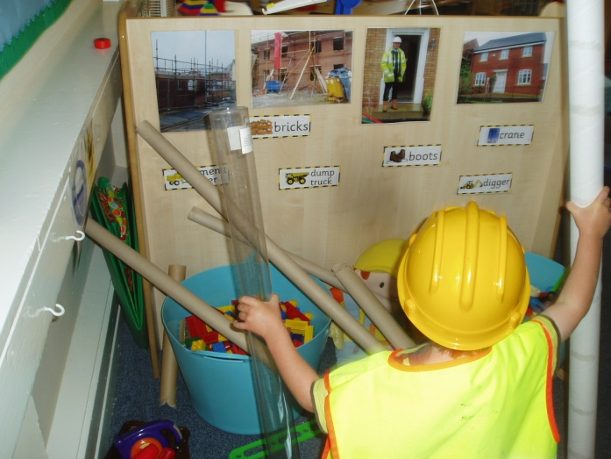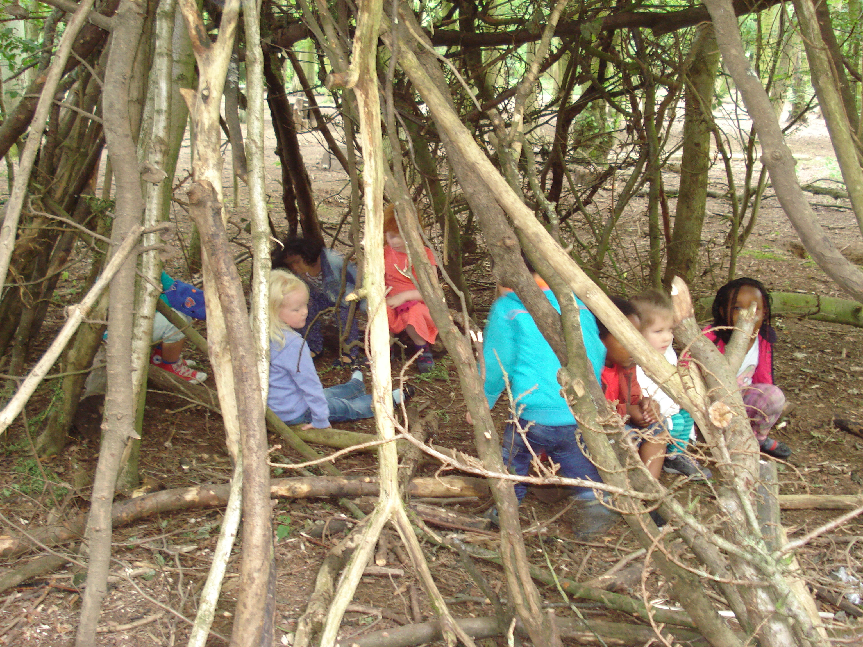

Using tubes for scaffolding in our Pre-School Children enjoying our
Construction Area. annual visit to Coombe Abbey

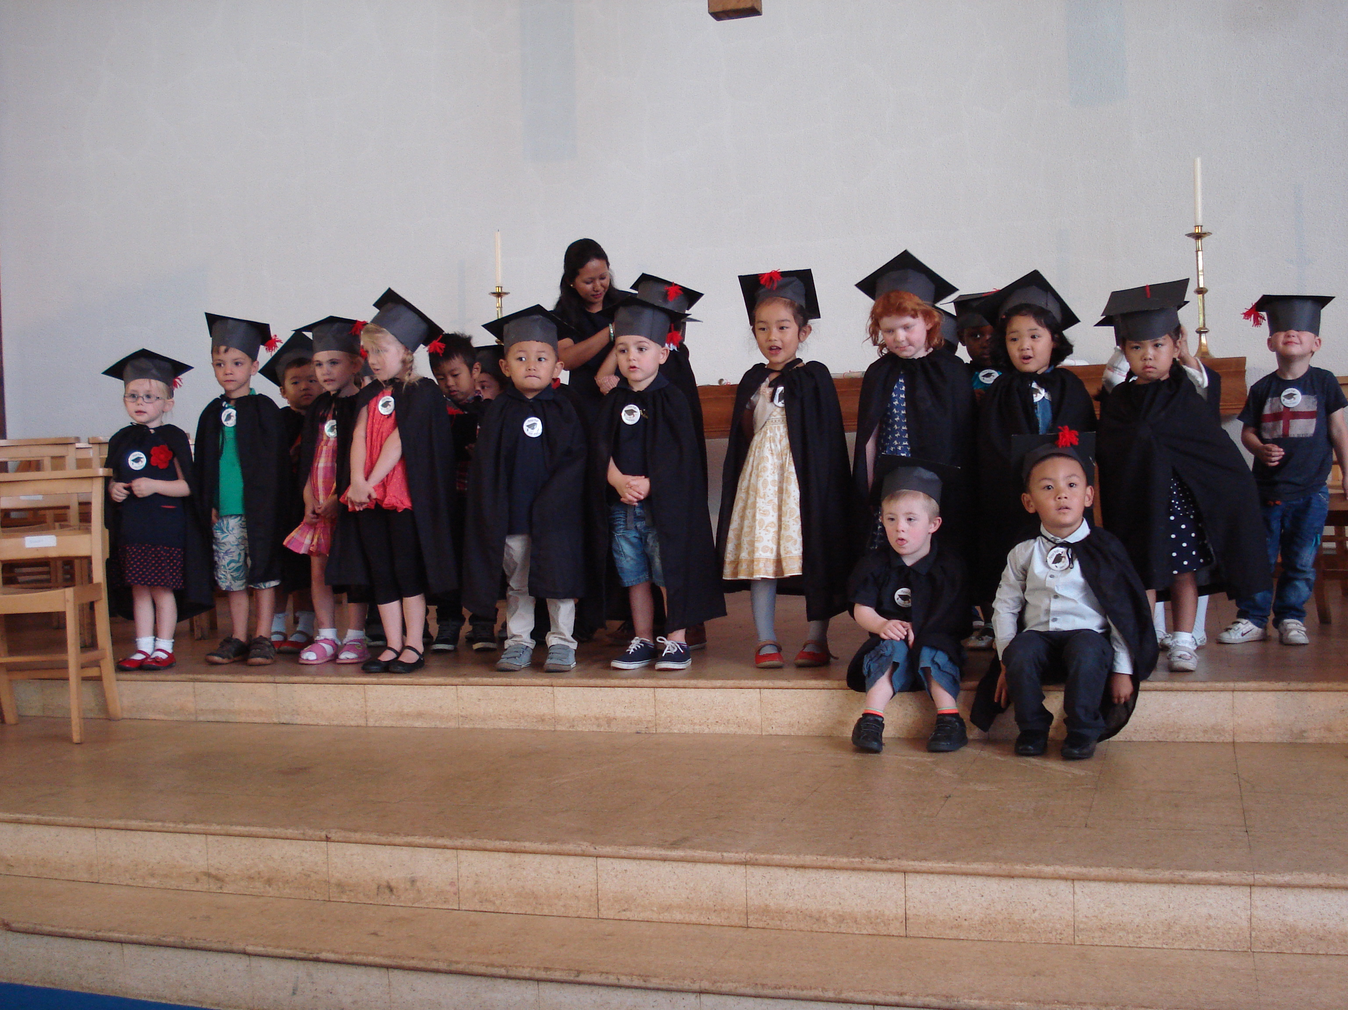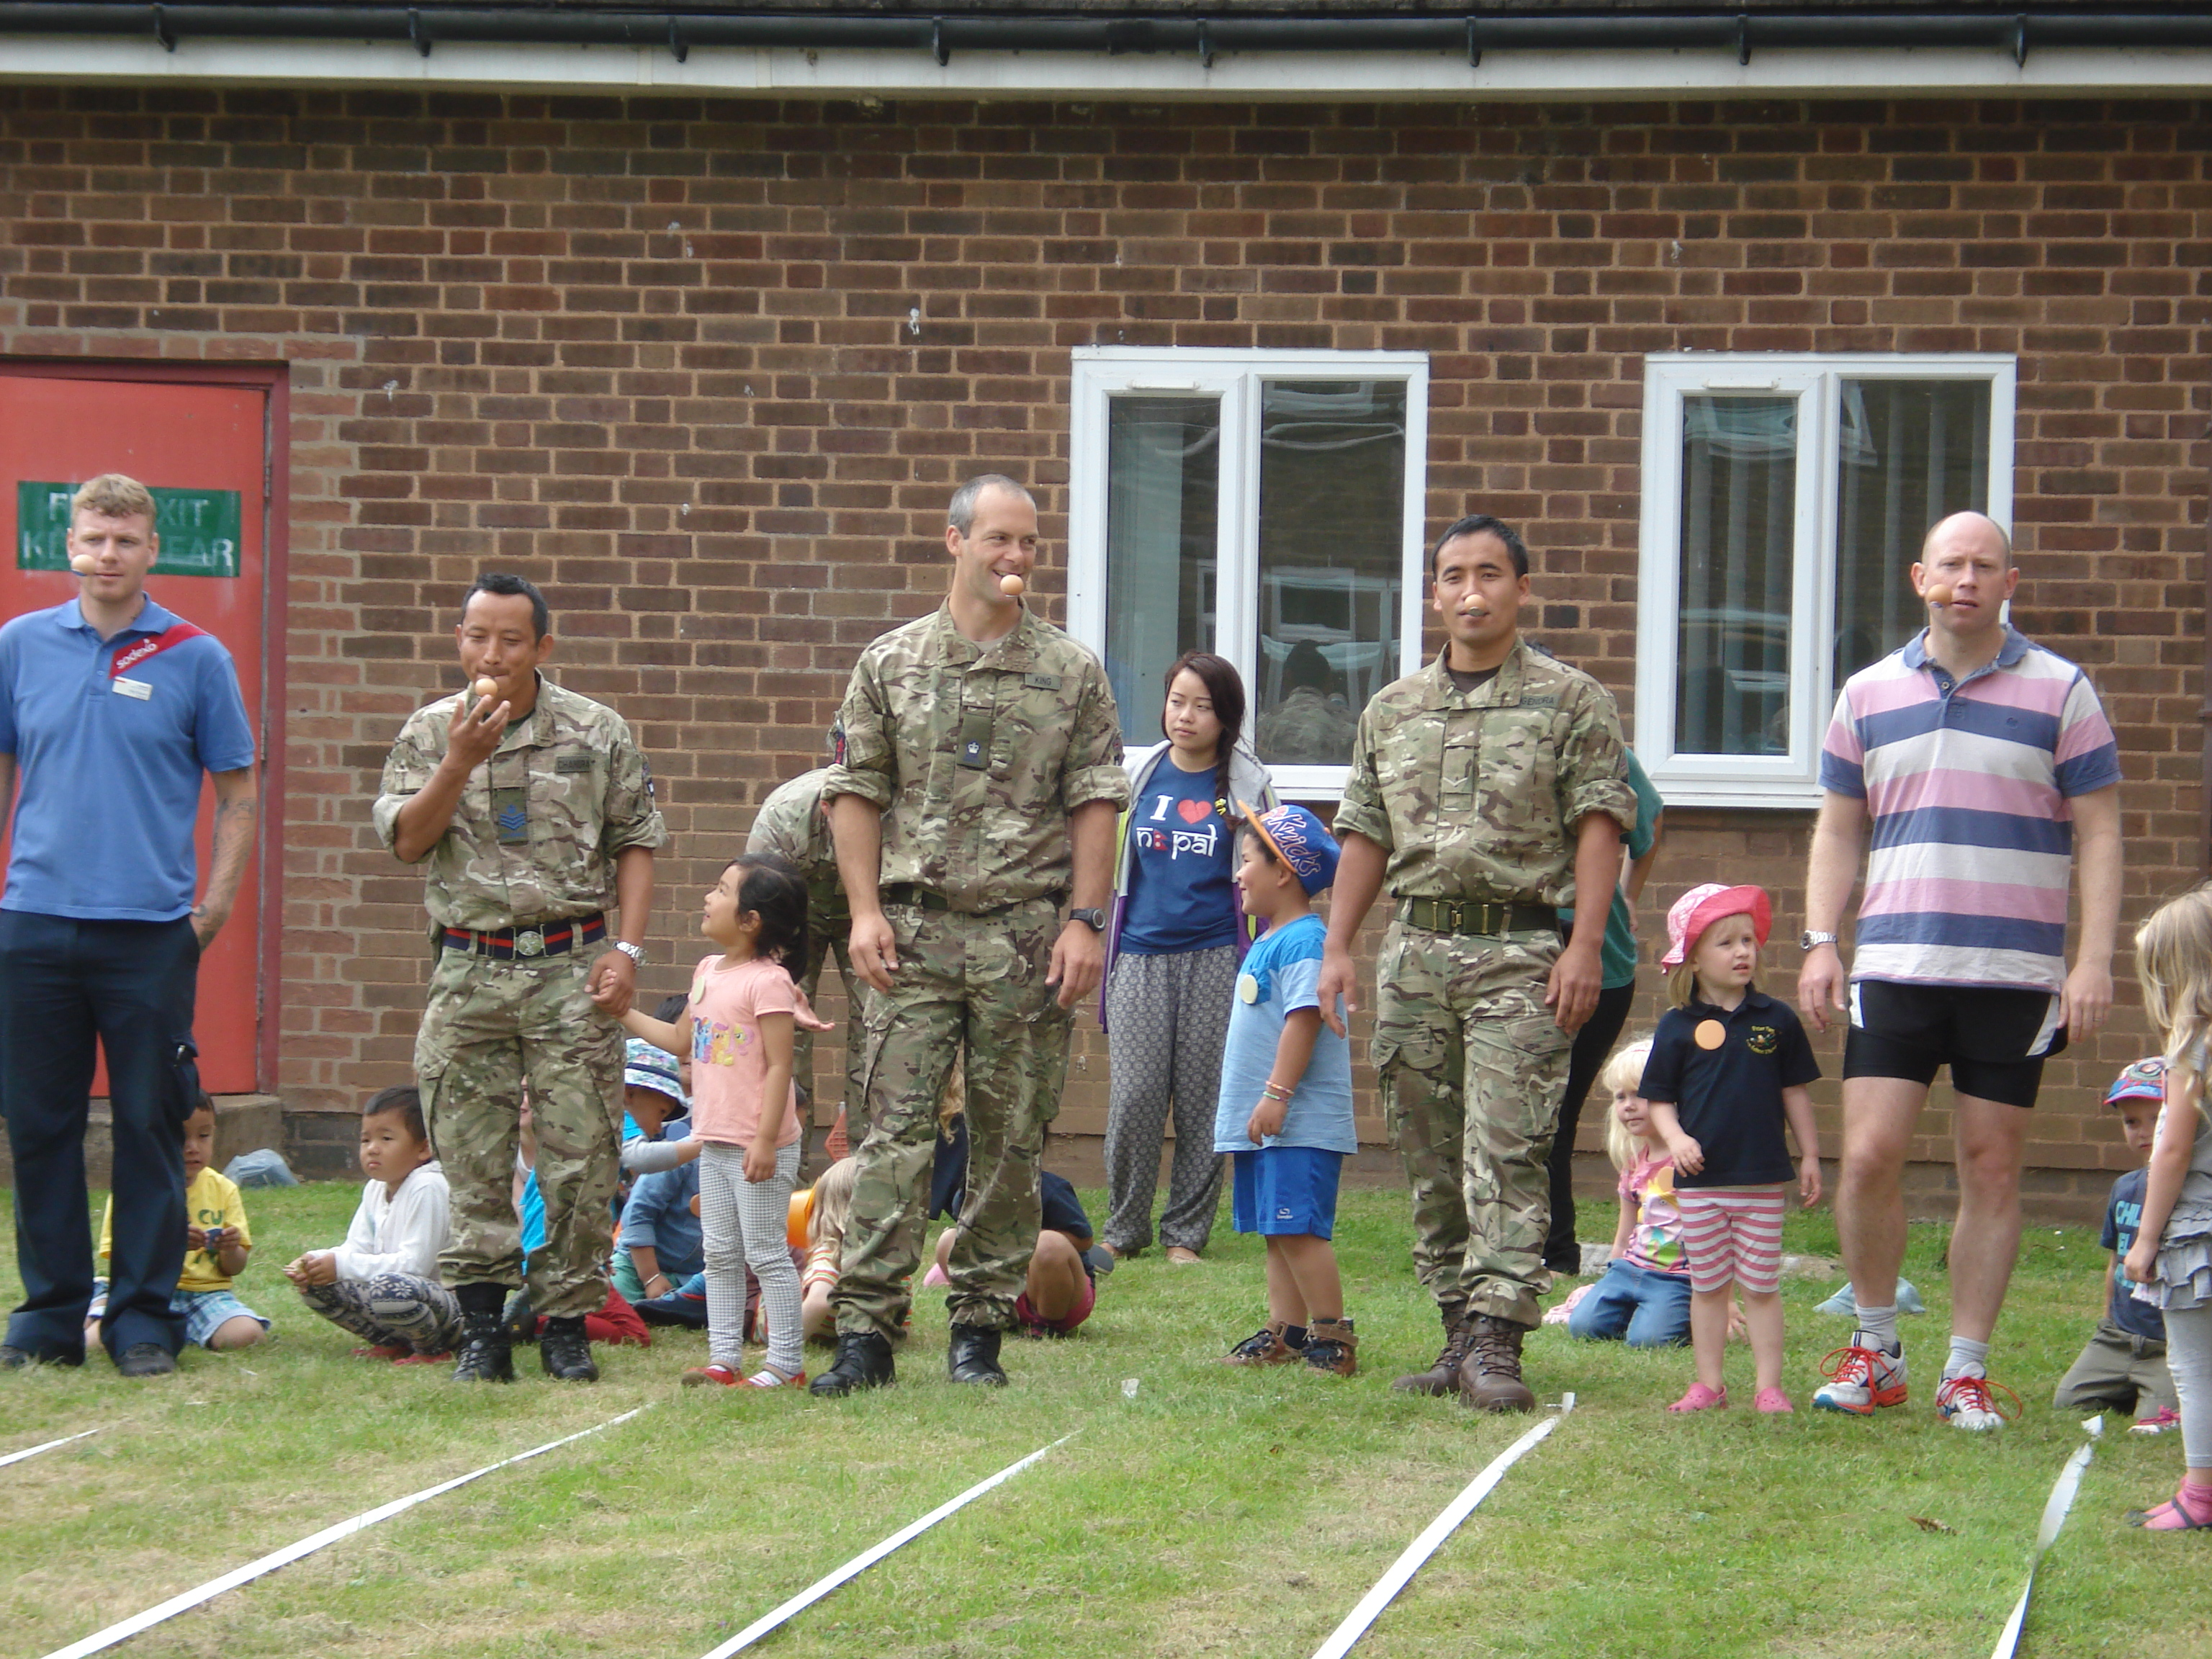

Celebrating the graduation of our Pre-School Competitive Daddies joining in on
Children in church. our sports day.

